What is a think board?
Think boards allow students to visually represent their thoughts and ideas on a subject. Students can then find links between these thoughts and ideas.

Think board example: camera
Here is an example of using a think board to link different ideas and thoughts around the concept of the camera.

People: Who uses this? Who does this affect?

Skills: What skills do we need to use the subject?

Symbols: What are the common symbols related to the subject?

Jobs/careers: What jobs would use the subject?

Visual representation: What images represent the subject?

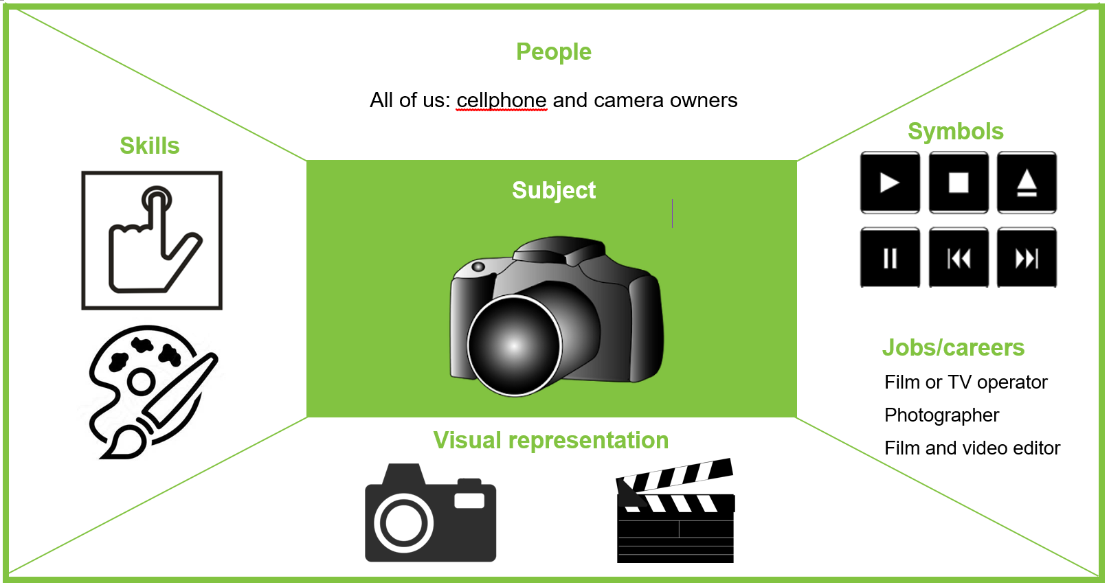

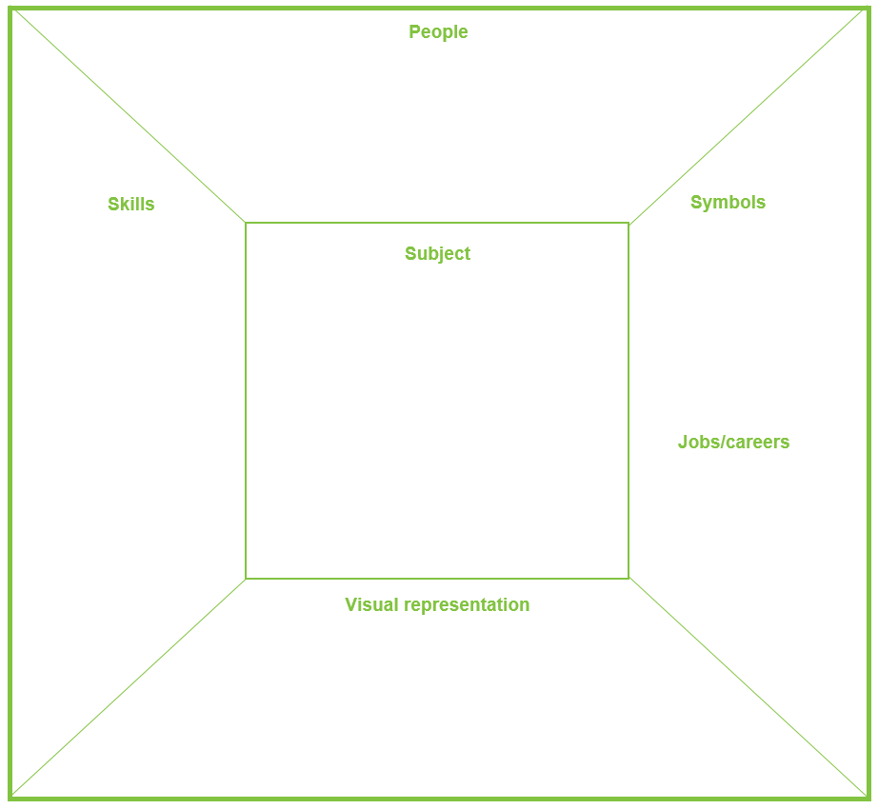

Acknowledgement: Whaea Rona Mulligan, senior teacher of the Senior School and Year 7 and 8 teacher,
Tairangi School, Porirua.

